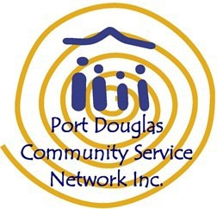
STATEMENT OF COMMITMENT
The safety and wellbeing of children
and the protection of children from harm
The Port Douglas Community Service Network Inc supports the rights of children and is committed to ensuring the safety, welfare and wellbeing of children in the Port Douglas Neighbourhood Centre and Family Support Hub.
The Port Douglas Community Service Network Inc is committed to:
- acting in the best interests of children
- responding to allegations of harm resulting from the conduct or actions of any person including that of employees, volunteers and visitors.
- requiring all employees, volunteers, visitors and service users to model and encourage behavior that upholds the dignity and protection of children from harm.
- ensuring all staff and volunteers are equipped with the knowledge, skills and awareness to support the protection of children
- ensuring physical environments promote safety and wellbeing, while minimising the opportunity for children to be harmed
At all times, the Port Douglas Community Service Network Inc works within our Child and Youth Risk Management Strategy which includes having relevant policies, procedures and training in place to effectively address the safety and wellbeing of children in our Centre.

